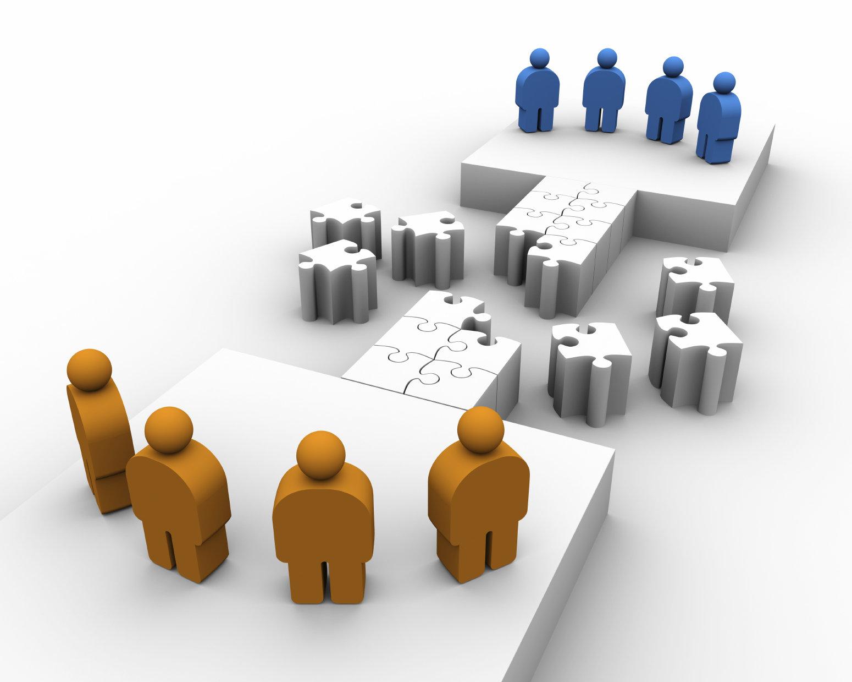

TFS Integration Tools

The Microsoft Visual Studio TFS Integration Tools is a suite of tools, built on top of the TFS Integration Platform, that facilitate integration between external systems and Team Foundation Server. The suite includes tools for connecting TFS to IBM® Rational® ClearCase® and IBM® Rational® ClearQuest® as well as to other Team Foundation Servers. Additionally, the suite provides a framework and fully supported SDK, allowing 3rd party developers to develop their own bridges between TFS and external systems.

The suite enables the development of two major classifications of tools, namely tools that move data unidirectionally into Team Foundation Server, and tools that synchronize data bidirectionally.

The TFS Integration tools and developer SDK are both fully-supported by Microsoft and available as a free [download](http://go.microsoft.com/fwlink/?LinkId=193029&clcid=0x409)[1] from Microsoft.com.

|  |  |  |
| --- | --- | --- |
| Proven Technology *Version-to-version upgrade of Team Foundation Server is easily accomplished through the TFS setup process.*  *This toolset is not required for those scenarios.*  Designed from the ground up the TFS Integration Tools have been used and hardened both as part of Microsoft internal dogfooding, synchronizing in excess of 11 million version control files and 2.8 million work item versions in a single deployment, and as part of several real-world customer environments. | Modular Platform The TFS Integration Tools are based on a pipeline managing the analysis and migration flow, which offers extension points to customize the standard pipeline process, by seamlessly dropping in custom adapters and add-ins. | Realtime Migrations Monitor and manage the migration process, defining version control and work item conflict resolutions and actioning unhandled conflicts real-time using the TFS Integration application and monitor the state of a sync with SSRS reports. |

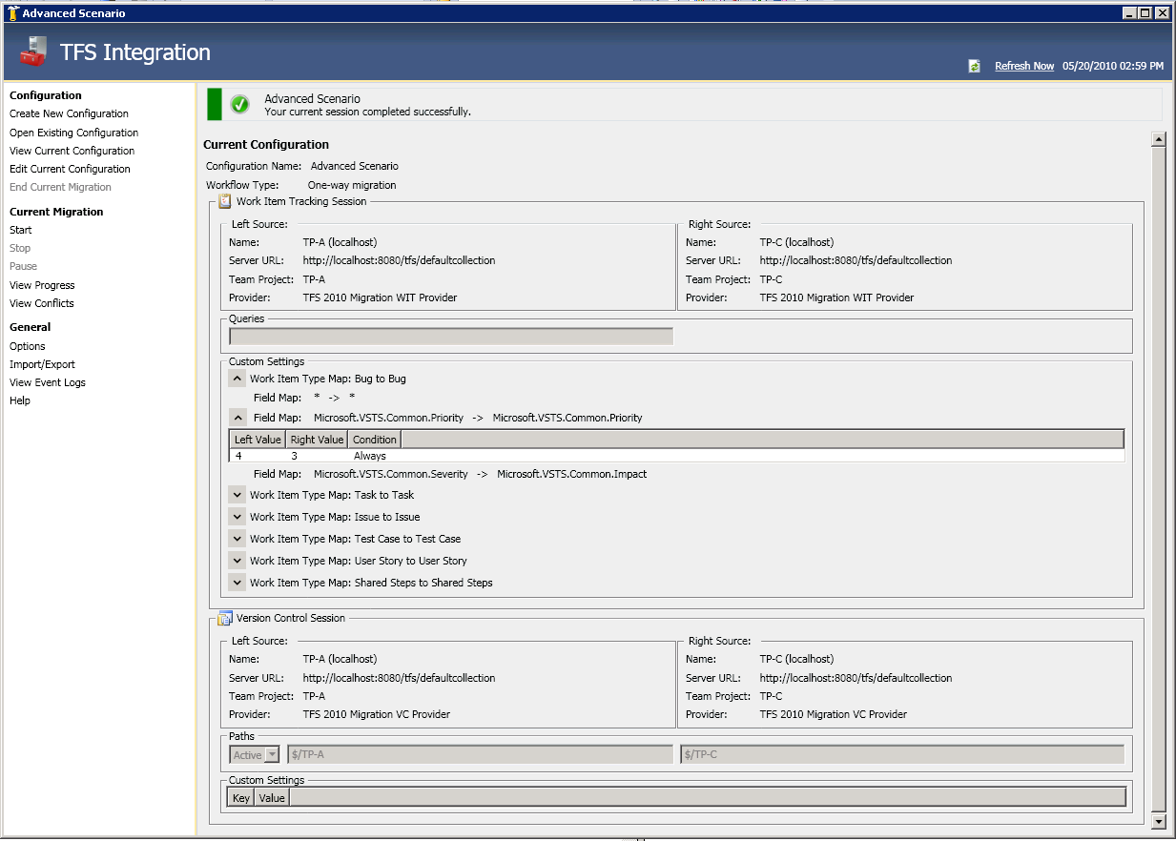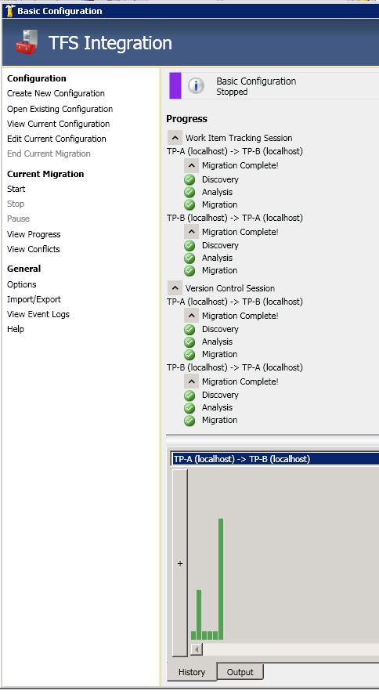

## Visual Studio ALM Rangers guidance at the core of the TFS Integration Tools

Visual Studio ALM Rangers provide technical guidance to support you with the planning, preparation and proof-of-concept evaluations needed to perform a migration or synchronization.

# Integration Examples

|  |  |  |
| --- | --- | --- |
| Snapshot Migration Migration of artifacts[2] from a given snapshot forward. Decide, for example, whether to migrate 2 months, or 2 weeks, or 1 day of history to TFS. *Complexity and cost of migrations increase as history increases … Customers should consider the cost/benefit of preserving history when moving to TFS.* Selected History Migration Migration of artifacts, from selected “interesting” points in time, allowing the history to be dialed. Selected history is a simple way to meet the need of teams trying to adhere to corporate standards while gaining the freedom to use Team Foundation Server (TFS). | **Archive Migration** Unidirectional migration of version control and work item artefacts with historical information**.** More complex than selected history or snapshot migration, but supported in cases where there is a requirement to know and prove the origin of artifacts as part of intellectual property compliance or regulatory concerns.  **Synchronization** Uni- or bidirectional synchronization of artifacts, using snapshot, selected or archive migration. | Custom Adapter Development Purpose-built integration infrastructure and hardened TFS adapters reduce the complexity of developing custom migration and synchronization tools using the TFS Integration Tools SDK and associated guidance.Further references TFS Integration Platform Codeplex Site <http://www.codeplex.com/TFSIntegration>  Team Foundation Server Migration and Integration Solutions <http://msdn.microsoft.com/en-us/teamsystem/bb840033.aspx>  Visual Studio ALM Rangers Site <http://msdn.microsoft.com/en-us/teamsystem/ee358786.aspx>  Rangers TFS 2010 Upgrade Guidance <http://vs2010upgradeguide.codeplex.com> |

|  |  |  |  |
| --- | --- | --- | --- |
| TFS Integration Tools Feature Matrix | Supported | Planned[3] | 3rd-Party |
| **Development Platform Support** |  |  |  |
| Software Development Toolkit | ● |  |  |
| Sample Code | ● |  |  |
| Technical Documentation | ● |  |  |
| Getting Started Hands-on-labs (HOL) | ● |  |  |
| Guidance Documentation | ● |  |  |
| **Migration** |  |  |  |
| TFS 2005 🡪 TFS 2008 | ●[4] |  |  |
| TFS 2008 🡪 TFS 2010 | ●[5] |  |  |
| IBM Rational ClearCase 7.x 🡪 TFS 2010 | ● |  |  |
| IBM Rational ClearQuest 7.x 🡪 TFS 2010 | ● |  |  |
| Perforce 🡪 TFS 2010 |  |  | ● |
| HP QualityCenter 🡪 TFS 2010 |  |  | ● |
| Subversion 🡪 TFS 2010 |  | ● |  |
| **Synchronization** |  |  |  |
| TFS 2005 🡨🡪 TFS 2008 | ● |  |  |
| TFS 2008 🡨🡪 TFS 2010 | ● |  |  |
| IBM Rational ClearCase 7.x 🡨🡪 TFS 2010 | ● |  |  |
| IBM Rational ClearQuest 7.x 🡨🡪 TFS 2010 | ● |  |  |
| Perforce 🡨🡪 TFS 1010 |  |  |  |
| HP QualityCenter 🡨🡪 TFS 2010 |  |  | ● |
| Subversion 🡨🡪 TFS 2010 |  | ● |  |
| **Samples** |  |  |  |
| SharePoint 🡨🡪 TFS | ● |  |  |
| File 🡨🡪 TFS |  |  |  |

1. http://go.microsoft.com/fwlink/?LinkId=193029&clcid=0x409
2. Artifacts currently include Version Control and Work Item data.
3. No delivery schedules for planned feature support are available at this stage.
4. An in-place upgrade is the recommended strategy to migrate from TFS 2005 to TFS 2008.
5. An in-place upgrade is the recommended strategy to migrate from TFS 2008 to TFS 2010.

   This material is provided for informational purposes only. Microsoft makes no warranties, express or implied.